“I Finally Stopped Losing My Hair” — A Review of LMCHING’s Honest, Hopeful Blog Post
(Read it on LMCHING Blog | Explore more at LMCHING.com)
Let’s be honest — hair loss is terrifying. It’s one of those things you don’t think about until it happens to you. One day your hair feels full and alive, and the next, you start finding strands everywhere — on your pillow, in your brush, down the shower drain. And along with it goes a little piece of your confidence.
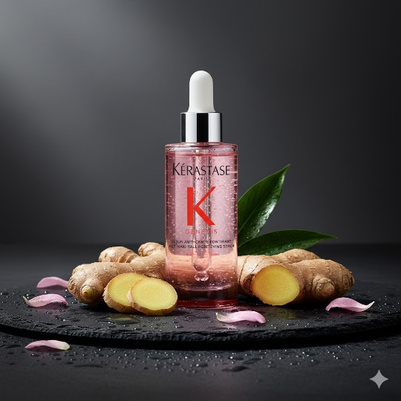
That’s why “The Day I Stopped Losing My Hair — And What Actually Worked” from LMCHING hits so differently. It’s not just another beauty blog post — it’s real, raw, and deeply relatable. The author doesn’t hide behind filters or fancy jargon. They just tell the truth: what it felt like to lose their hair and what it took to finally stop it.
It Starts with Honesty
The story opens with vulnerability — tears in the shower, frustration, fear. It feels like a conversation you’d have with a close friend who’s finally ready to say, “I’m struggling.” But instead of staying in that pain, the author takes readers on a journey of rediscovery — learning to understand the scalp, not just the hair.
That single shift in mindset — realizing that the scalp is the foundation — becomes the breakthrough moment. As the author beautifully puts it, “Your hair isn’t the problem; your scalp is.” And suddenly, it all makes sense.
The Science Made Simple
What’s refreshing about this piece is how easy it is to understand. The author explains five hidden causes of scalp damage — buildup, inflammation, poor circulation, pH imbalance, and hormonal sensitivity — in a way that’s clear and helpful, not intimidating.
You walk away not just feeling comforted, but educated. You actually learn how to treat your hair better without being bombarded by product ads or unrealistic claims.
Progress That Feels Real
What I love most about this post is its honesty about time. The author doesn’t pretend there’s a “three-day miracle cure.” They share their timeline openly — what happened after two weeks, six weeks, three months, and beyond. That realism gives hope without false promises.
Their advice — gentle scalp massage, pH-balanced cleansers, patience — feels doable for anyone. It’s not about perfection; it’s about progress.
The Heart Behind the Story
At its core, “The Day I Stopped Losing My Hair” isn’t just about regrowth — it’s about self-kindness. The author reminds us that healing, whether it’s our skin, our hair, or our confidence, takes time and love.
That’s what makes this LMCHING blog so special. It turns something painful into something empowering — showing that even in the smallest routines, we can reclaim control and peace.
If you’ve ever looked at your reflection and felt that sting of frustration, this article will make you feel seen — and hopeful again.
You can read the full story on LMCHING.com — and trust me, it’s worth every word.

